PERFORMANCE COMPARISON OF NONLINEAR CONTROLLERS FOR NOMINAL AND PERTURBED MODEL OF BUCK CONVERTER
Iftikhar Ali, Narayan Longani, Fahad Mumtaz Malik

College of Electrical and Mechanical Engineering, National University of Science and Technology, Rawalpindi, Pakistan
engriftikharali89@yahoo.com, narayanlongani@gmail.com, malikfahadmumtaz@yahoo.com
ABSTRACT—Development in electronics has also reduced the size of electronic items. Variations in supplied voltage or in load, external disturbances, parametric uncertainty or measurement error cause fluctuation in output of DC supply. In this paper use of nonlinear controllers for the buck converter is presented which gives stable output in every condition as discussed. The nonlinear controllers used are backstepping and integral sliding mode controller. Performance of these controllers is also compared with nominal and perturbed parameters.

Keywords—Buck Converter, Integral Sliding Mode Control, Backstepping.

INTRODUCTION
Day by day use of electronics equipment is increasing. Electronic equipments usually come with DC supply. For proper operation a robust supply is required. These power supplies of electronic equipments are using converter. Many factors like load variations, effect of temperature, parametric uncertainties, measurement error causes fluctuations in output voltage of converter [1,2,3]. These fluctuations of converter can be overcome with different control techniques [4].
The Sliding Mode Control is one of the nonlinear control techniques which is robust to both parametric uncertainties and external disturbances [5,6]. Due to robustness of sliding mode controller it can provide us a good regulation on different operating ranges [7]. Comparison of various control methods like sliding mode control, PI and fuzzy logic controllers on Buck converters [8]. From [9] and [10] it is clear that sliding mode control of single phase DC-DC buck is robust to the load variation, variation in input, parameter uncertainties and operating point changes. Ref [11] shows that transients effect and output ripple voltage can be improved with using SMC for the two phase synchronous buck converter. Others also show that a number of approached for sliding mode controllers are not effective when variations in load current and supplied voltages are high [12]. Study of nonlinear backstepping controller techniques for buck converter reveals that its results are very effective than proportional integral (PI) control and also efficient for unknown load case [13,14,15].. Huangfu Yigeng et al. made comparison of types of sliding mode controller with PI and PID for the buck converter, results clearly shows the poor robustness of PI, PID compared to sliding mode controller [16,17].
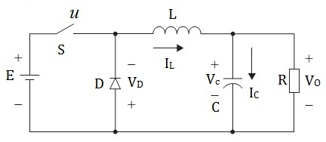
Fig. 1 DC-DC Buck Converter
In this paper there is comparison of two nonlinear control techniques used for buck converter under nominal conditions and perturbed conditions.

BUCK CONVERTER
Step down DC/DC converter is referred as Buck Converter in fig 1. Differential model of buck converter shows that it is a minimum phase system because its relative degree is two. In fig. 1, L, R and C are inductance, resistance (load) and capacitance respectively. Where E is the source voltage, S is the switch, V_{O} is output voltage and D is diode and u defines the duty cycle of input.
The mathematical model for buck converter is obtained using Kirchhoff’s current and voltage laws. The inductor current I_{L} is modeled as state variable x₁ and capacitor voltage V_{C} are modeled as state variables x₂, then the state space model of buck converter will be
${\dot{x}}_{1}=-\frac{x_{2}}{L}+\frac{uE}{L}$ (1)
${\dot{x}}_{2}=\frac{x_{1}}{C}-\frac{x_{2}}{RC}$ (2)

NON LINEAR CONTROLLERS
Normally nonlinear controllers are used because most of the systems are nonlinear. For proper operations of converters in the steady state closed loop controllers are used [18]. Usually, in order to keep closed loop control system working, PI and PID are most common control techniques are used. In this paper integral sliding mode & backstepping controllers are designed and implemented for the model of buck converter.

Backstepping control
The Backstepping Controller is one of the robust nonlinear controllers used. Back stepping technique uses divide and conquers. The model defined in (1) & (2), x₂ is output voltage and x₁ is Inductor current. The error dynamics will be defined as
$e_{1}=x_{2}-x_{2d}$ (3)
Where e₁ is given Error and x_{2d} is desired output voltage. Using the Lyapunov function as,
$V_{1}=\frac{1}{2}{e_{1}}^{2}$ (4)
${\dot{V}}_{1}=e_{1}\left({\dot{x}}_{2}-{\dot{x}}_{2d}\right)$ (5)
Using (2)
${\dot{V}}_{1}=e_{1}\left(\frac{x_{1}}{C}-\frac{x_{2}}{RC}-{\dot{x}}_{2d}\right)$ (6)
As $\frac{x_{1}}{C}$ act as virtual control, now using Backstepping technique e₂ will be defined as
$e_{2}=\frac{x_{1}}{C}-\frac{x_{2}}{RC}-{\dot{x}}_{2d}+αe_{1}$ (7)
Similarly other Lyapunov Function will be
$V_{2}=\frac{1}{2}{e_{2}}^{2}$ (8)
${\dot{V}}_{2}=e_{2}\left(-\frac{x_{2}}{LC}+\frac{uE}{LC} -\frac{x_{1}}{RC^{2}}+\frac{x_{2}}{R^{2}C^{2}}-{\ddot{x}}_{2d}+α{\dot{e}}_{1} \right)$ (9)
Now the composite Lyapunov function will be
$V=V_{1}+V_{2}$ (10)
$\dot{V}=e_{1}\left(\frac{x_{1}}{C}-\frac{x_{2}}{RC}-{\dot{x}}_{2d}\right)+e_{2}\left(-\frac{x_{2}}{LC}+\frac{uE}{LC} –\frac{x_{1}}{RC^{2}}+\frac{x_{2}}{R^{2}C^{2}}-{\ddot{x}}_{2d}+α{\dot{e}}_{1} \right)$ (11)
Using (7) and some mathematical operation we get
$\dot{V}=-α{e_{1}}^{2}+e_{2}\left(e_{1}-\frac{x_{2}}{LC}+\frac{uE}{LC} –\frac{x_{1}}{RC^{2}}+\frac{x_{2}}{R^{2}C^{2}}-{\ddot{x}}_{2d}+α{\dot{e}}_{1} \right)$ (12)
From (12) we will define such control input that $\dot{V}$ is negative definite, then control will be
$u=\frac{LC}{E}\left(-e_{1}+\frac{x_{2}}{LC}+ \frac{x_{1}}{RC^{2}}-\frac{x_{2}}{R^{2}C^{2}}+{\ddot{x}}_{2d}-α{\dot{e}}_{1} -βe_{2} \right)$ (13)
Where α and β are constants and greater than zero. Control effort derived in (13) is backstepping control for the buck converter [19]. Now after deriving backstepping control law, we will derive another control law using Integral sliding mode for the buck converter.

Integral Sliding Model Controller
The Integral Sliding Mode Controller (ISMC) is robust nonlinear controllers. The integral sliding mode controller also works in two steps like sliding mode controller, first step is reaching phase and other step is sliding phase. Control effort of ISMC is designed in such away that initially move the system dynamics to the sliding surface, after reaching, system dynamics will slides on the surface until it reaches equilibrium point. The integral sliding mode controller shows robustness to load variation and parametric uncertainty.
Uncertainty occurs in values of capacitance and inductance, and also variations occurs in load and input voltage source of DC-DC buck converter. Sliding mode controller has disadvantage of chattering i.e. finite amplitude and frequency oscillations occurs because of sign function. They are reduced with saturation or tangent hyperbolic function rather than use of sign function. Higher order SMC also reduce chattering effect because chattering affects the performance of power system. To remove steady-state error we add integrator to the controller. Similarly we add integral control to sliding mode controller
to achieve regulation with no steady state error. We will design Integral sliding mode control for DC-DC buck converter. Using augmented integrator as
${\dot{e}}_{0}=x_{2}-x_{2d}$ (14)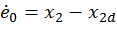
We obtain the augmented system as
${\dot{e}}_{0}=e_{1}$ (15)
${\dot{e}}_{1}=e_{2}$ (16)
${\dot{e}}_{2}=\frac{1}{LC}\left(uE-x_{2}\right)-\frac{{\dot{x}}_{2}}{RC}$ (17)
The sliding mode surface is selected as
$s=k_{0}e_{0}+k_{1}e_{1}+k_{2}e_{2}$ (16)
Taking derivatives to both sides we get
$\dot{s}=k_{0}e_{1}+k_{1}e_{2}+\frac{k_{2}}{LC}\left(uE-x_{2}\right)-\frac{k_{2}{\dot{x}}_{2}}{RC}$ (17)
Control effort will be derived such that$s\dot{s}<0$, conditions is satisfied. So control input will be
$u=-ksat\left(\frac{s}{ϵ}\right)=-ktanh\left(\frac{s}{ϵ}\right)$ (18)
Where k > 0 and ϵ is a positive constant (0 < ϵ < 1) . Now in next section results are presented after applying these nonlinear controllers to the model of buck converter. The classical and continous sliding mode controllers can be related as if the relative degree is one the controller become PI controler followed by saturation or signum or tangent hyperbolic function and when relative degree of a system is two then the controller become PID classical controller followed by saturation or tangent or signum funtion [19].

SIMULATION RESULTS
Simulation results are for the nonlinear control effort designed in the previous section using nonlinear controllers for the buck converter are shown. Different parameters for the simulations are used as L = 4µH, C = 10mF, E = 10V, V_{O} = 5V and random load, R, was used with mean value of 5.0127Ω. Variation in load, input supply and parametric variation are considered and for them results are also represented. For Simulations, SIMULINK of MATLAB R2013a was used and total simulation time was 0.01 sec.

Backstepping Results
Results of backstepping controller for buck converter for output of 5 Volts, with nominal parameters and with 10% perturbation added to system parameters and source voltage are presented in fig. 2 & in fig. 3. The parameter alpha, α = 99 and β = 0.4. From the graphs we can see the robustness of backstepping controller toward perturbation.
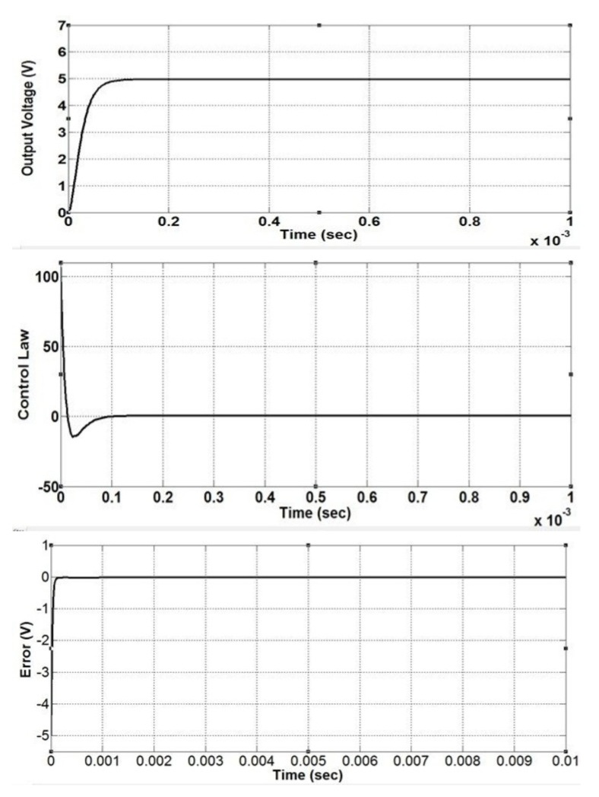Fig. 2 Results of Buck converter with nominal parameters using backstepping controller. First graph shows output voltage, second graph is the control effort and last graph is error plotted between the desired & obtained output voltage of buck converter.
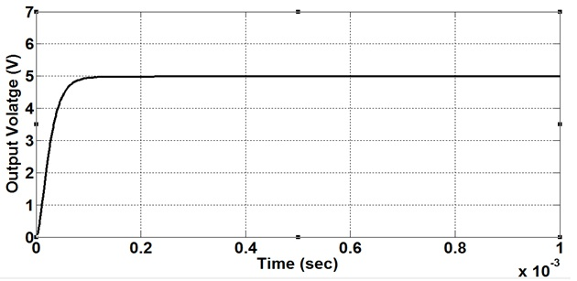
Fig. 3 Output Voltage of Buck Converter with perturbed parameters using Backstepping controller.

Integral Sliding Mode Control
Results of integral sliding mode controller for buck converter for output of 5 Volts, with nominal parameters and with 10% perturbation added to system parameters and source voltage are presented in fig. 4 & in fig. 6. The values of K₀ = 0.0029599991, K₁ = 0.000999991, and K₂ = 3e-07 are obtained using The Jury Stability Test for discrete time systems [20]. From the graphs we can see the robustness of integral sliding mode controller toward perturbation.
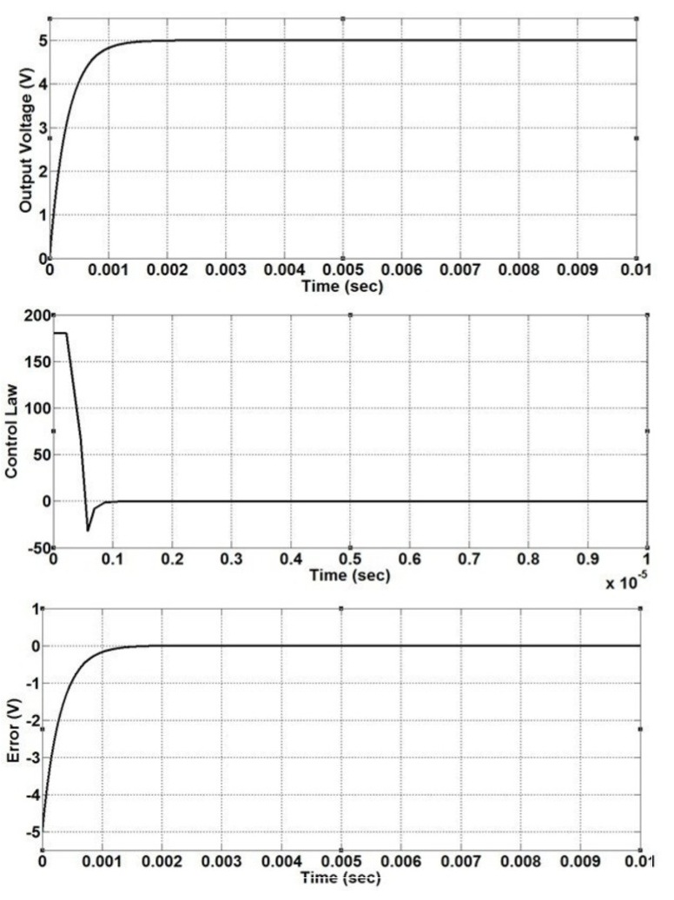Fig. 4 Results of Buck converter with nominal parameters using integral sliding mode controller. First graph shows output voltage, second graph is the control effort and last graph is error plotted between the desired & obtained output voltage of buck converter.
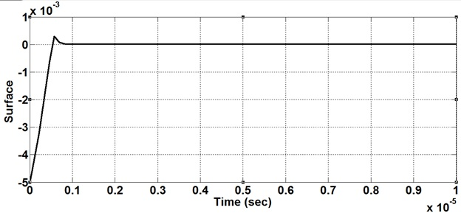Fig. 5 Results of sliding surface
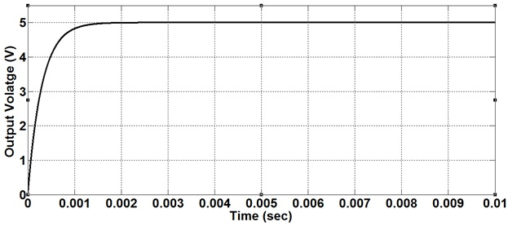Fig. 6 Output Voltage of Buck Converter with perturbed parameters using Integral Sliding Mode controller

Table 1. Parameters Of Output Voltage
Parameter / Controller | Backstepping Controller | Integral Sliding Mode Controller
RESULTS WITH NOMINAL PARAMETERS
Rise Time (Sec) | 4.6520e-05 | 6.5952e-04
Settling Time (Sec) | 8.2204e-05 | 0.0012
Overshoot | 0.0016 | 0
Peak Time (Sec) | 3.4006e-04 | 0.0100
RESULTS WITH PERTURBED PARAMETERS
Rise Time (Sec) | 4.6567e-05 | 6.5956e-04
Settling Time (Sec) | 8.2298e-05 | 0.0012
Overshoot | 0.0016 | 4.0671e-05
Peak Time (Sec) | 3.3690e-04 | 0.0100

CONCLUSION
From simulation of both the controllers, different features of output voltage of buck converter like rise time, settling time, overshoot and peak time are compared. From the results we can see that both controllers achieve stability in span of negligible time. From Table I. settling time of backstepping controller is less than that of integral sliding mode controller for both nominal and perturbed parameters case. The integral sliding model Controller is having advantage of overshoot, there is no overshoot with nominal parameters while negligible when perturbation is added to parameter and source voltage, while backstepping controller shows the same overshoot for both cases. Now it’s up to the requirement of user, if user is having a trade-off for overshoot then he can use Integral sliding mode control and if he requires quick stabilization, Backstepping controller is good candidate.

REFERENCES
- N. Mohan, T. M. Undeland, and W. P. Robbins, “Power Electronics Converters, Applications and Design”, John Willey and Sons Inc, 3rd edition, 2004.
- A.I. Pressman, K. Billings, and T. Morey, "Switching power supply design”, McGraw-Hill Professional, 2009.
- E. Acha, “Switching Power Supply Design”, McGraw-Hill, 1997.
- A.J. Forsyth, and S.V. Mollow, “Modelling and control of dc-dc converters”, IEEE Power Engineering Journal, 12(5): 229–236(1998).
- N. M. B. Romdhane, and T. Damal, “Terminal Sliding Mode Feedback Linearization Control”, International Journal of Sciences and Techniques of Automatic Control & Computer Engineering, 4(1): 1174-1187(2010).
- B. Labbe, B. Allard, Xuefang Lin-Shi, Member, and D. Chesneau, “An Integrated Sliding-Mode Buck Converter With Switching Frequency Control for Battery-Powered Applications”, IEEE Transactions on Power Electronics, 28(9): 4318-4326(2013).
- Yu Ni, and Jianping Xu, “Study on Switching Power Converter with Discrete Global Sliding Mode Control”, 4th IEEE Conference on Industrial Electronics and Applications, pp 3394-3398, May 2009.
- V. S. C. Raviraj, and P. C. Sen, “Comparative study of proportional integral, sliding mode, and fuzzy logic controllers for power converters”, IEEE Transactions on . Industrial Application, 33(2):518–524(1997).
- H. Guldemir, "Study of Sliding Mode Control of DC-DC Buck Converter", Energy and Power Engineering, 3(4) :401-406(2011).
- Khalifa Al-Hosani, Vadim Utkin, and Andrey Malinin, “Sliding Mode Control for Industrial Controllers, Sliding Mode Control”, Prof. Andrzej Bartoszewicz (Ed.), ISBN: 978-953-307-162-6, InTech 2011,
- C. G. Wilson, J. Y. Hung, and R. N. Dean, “A Sliding Mode Controller for Two-Phase Synchronous Buck Converters”, 38th Annual Conference on IEEE Industrial Electronics Society, pp 2150 – 2155, Oct. 2012.
- M. Bensaada et. al, “Sliding Mode Controller for Buck DC-DC Converter”, 9th IEEE International Multi-Conference on Systems, Signals and Devices, pp 1-6, March 2012.
- R. S. Kumar, & S. G. Kumar, “Comparative Study of Proportional Integral and Backstepping Controller for the Buck Converter”, IEEE International Conference on Emerging Trends in Electrical and Computer Technology, pp 375 – 379, March 2011.
- M. L. McIntyre, M. Schoen, and J. Latham,“Simplified Adaptive Backstepping Control of Buck DC:DC Converter with Unknown Load”, 14th IEEE Workshop on Control and Modeling for Power Electronics (COMPEL), pp 1-7, June 2013.
- H. El Fadil, F. Giri, M. Haloua, H. Ouadi, “Nonlinear And Adaptive Control Of Buck Power Converters”, 42nd IEEE Conference on Decision and Control, 5: 4475 – 4480(20003).
- H. Yigeng, Ma Ruiqing, Xie En, and A. Miraoui, “A Robust Second Order Sliding mode conreoller for Buck Converter”, IEEE International Conference on Electrical Machines and Systems, pp 159-161, Oct 2010.
- H. Yigeng, Wang Bo, Ma Ruiqing, and Li Yuren, “Comparison for buck converter with PI, sliding mode, dynamic sliding mode control”, IEEE International Conference on Electrical Machines and Systems, pp 1-4, Oct 2012.
- Fang Lin Luo, Hong ye, and M. Rashid, “Digital Power Electronics and Applications”, Elsevier Academic Press, 2005.
- Hassan K. Khalil, “Nonlinear Systems”, Third Edition Prentice Hall, 2002.
[20] Katsuhiko Ogata, “Discrete Time Control Systems”, Second Edition, Prentice-Hall International, Inc, 1987.

